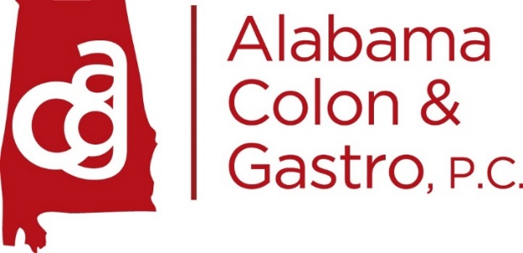

Procedures Policies for Procedures
Acknowledgment Form
- I have received my procedure prep instructions and my low residue diet. If this paperwork is lost or misplaced, I will be charged a $5 fee for a new copy. A copy of the procedure prep only is located on our website at alabamacolonandgastro.com for your convenience.
- I have received all my instructions from the scheduler about arrival time and location information.
- I understand that there is no penalty for rescheduling or canceling my procedure(s) at least 48 hours in advance.
- I will receive a reminder call from our office at least 48 hours in advance.
- Please understand we are not affiliated with Crestwood Medical Center and Huntsville Surgery Center scheduling departments, please call OUR office to cancel or reschedule your procedure(s).
- In order to provide our patients with the highest level of care, we have a procedure cancellation policy. I understand that if I have to cancel my procedure after 48 hours, I will be charged a cancellation fee of $75, and this must be paid before I can reschedule my procedure. This cancellation fee is not covered by your insurance. If there is a valid reason for canceling, please be prepared to provide documentation from an urgent care, emergency room, or from a physician or provider.
I have read the above information and my signature signifies that I understand Alabama Colon & Gastro, P.C.’s policies and procedures.

Signature____________________________________Date__________________
Print Name:__________________________________

